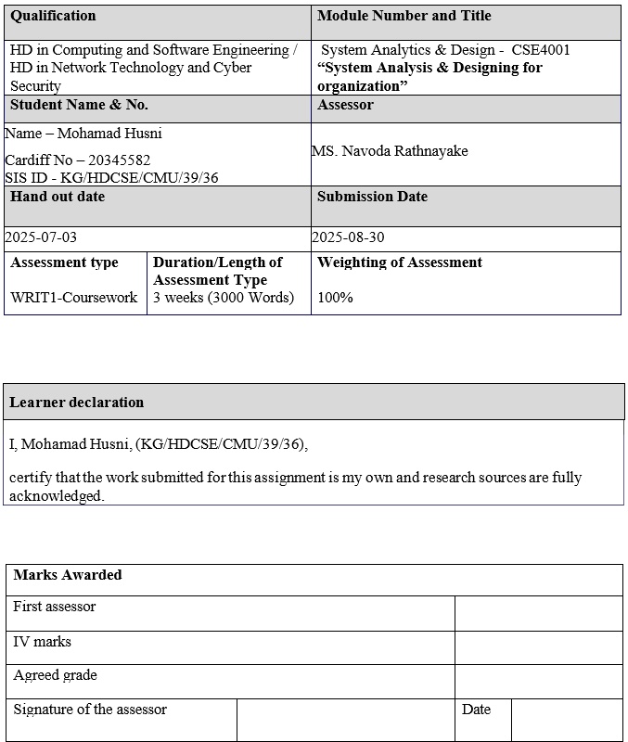

Table of Contents
Task 01 5
System Analysis & Design Report for Rt & Dk Consumers (Pvt) Ltd 5
1. Introduction to the Organization 5
2. Fact-Finding Techniques 6
3. Current Stock System and Survey Results 8
4. Proposed System and Requirement Gathering 9
Task 02 12
5. Standard Software Development Life Cycle 12
5.1. SDLC steps 12
5.2. SDLC applied to RT & DK 13
5.3. Software process models 17
Task 03 19
1. Context Level DFD 23
2. High Level DFD 24
3. Structured English Method 25
4. Decision Tree 26
2. Decision Table 26
5. Top Down Approach 27
6. Bottom Up Approach 27
7. Use Case Diagram 28
8. Sequence Diagram 29
9. UML Class Diagram 30
References 31

Figure 1 Managerial Level 4
Figure 2 5
Figure 3 6
Figure 4 6
Figure 5 6
Figure 6 6
Figure 7 6
Figure 8 6
Figure 9 17
Figure 10 21
Figure 11 22
Figure 12 24
Figure 13 24
Figure 14 24
Figure 15 25
Figure 16 25

Table 1 18
Table 2 18
Table 3 19
Table 4 19
Table 5 20
Table 6 20
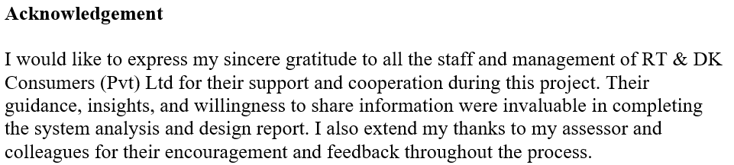
Table 7 24

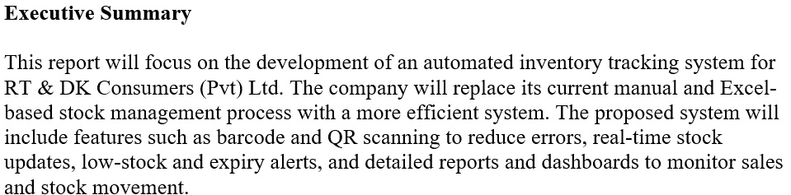
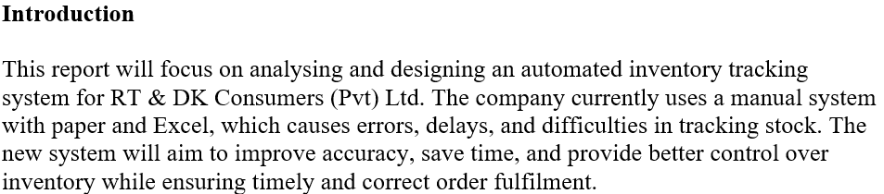
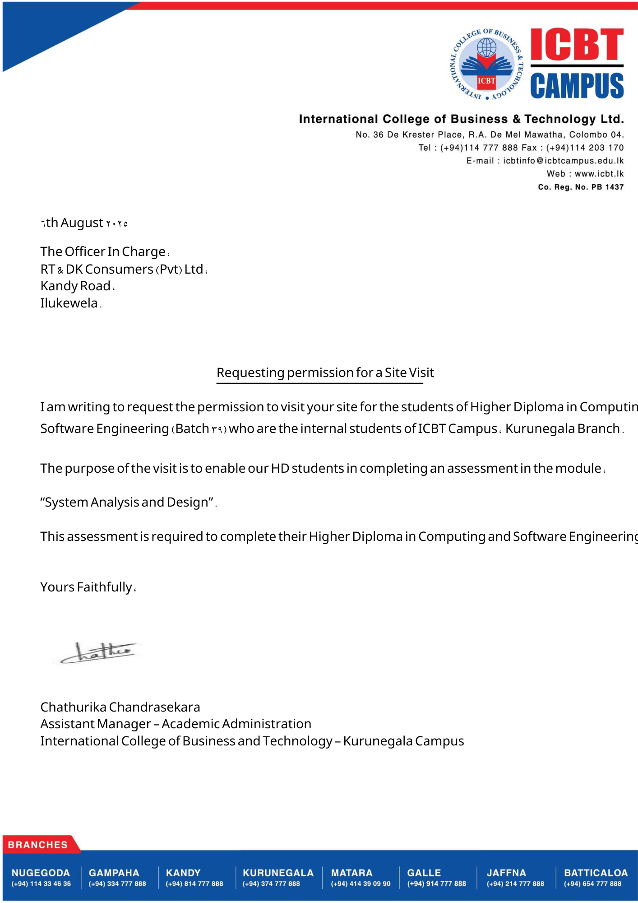

System Analysis & Design Report for Rt & Dk Consumers (Pvt) Ltd

Introduction to the Organization
RT & DK Consumers (Pvt) Ltd is a private company specializing in the supply of plastic essentials. The company is committed to delivering high-quality plastic products and excellent customer service.
Vision: “Trusted supplier of quality plastic essentials.”
Mission: “Be the best by providing high-quality plastic products and excellent service.”
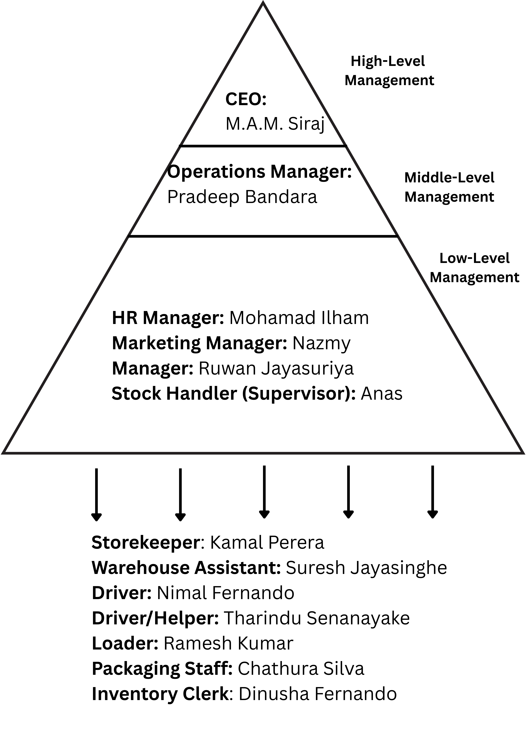
The company uses this management structure:
Figure 1 Managerial Level

Fact-Finding Techniques
To identify operational draw backs in RT & DK's information system, I followed three fact-finding approaches:
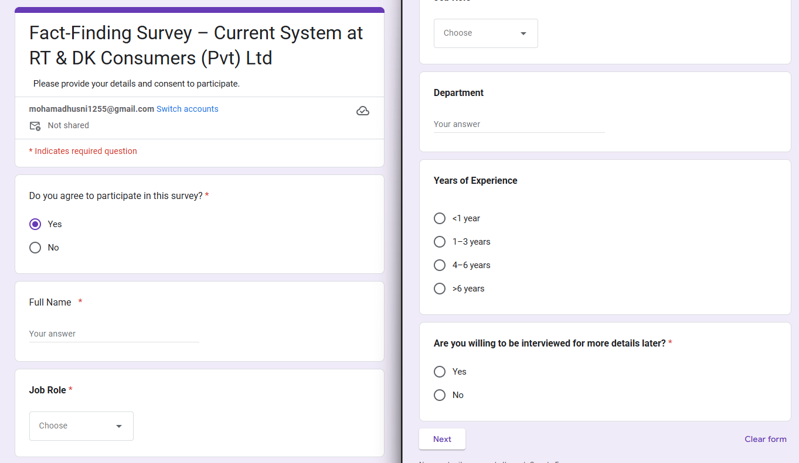
- Structured Survey (Primary)
Figure 2

- Conducted via Google Forms, questioners with Staffs.
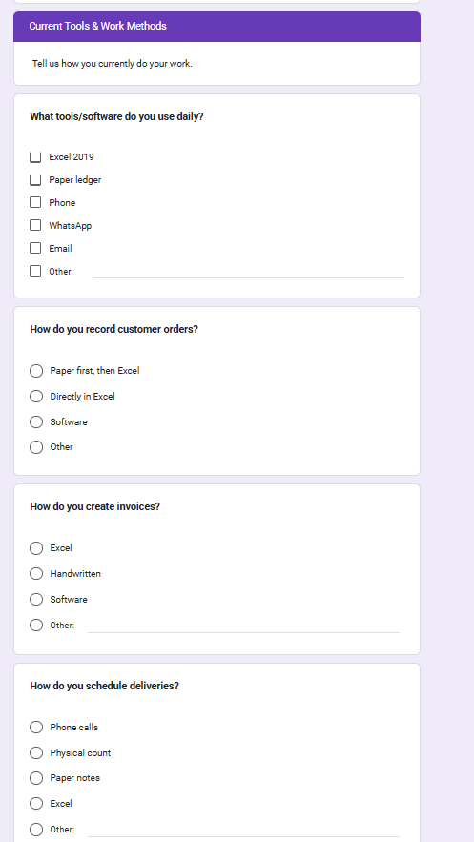
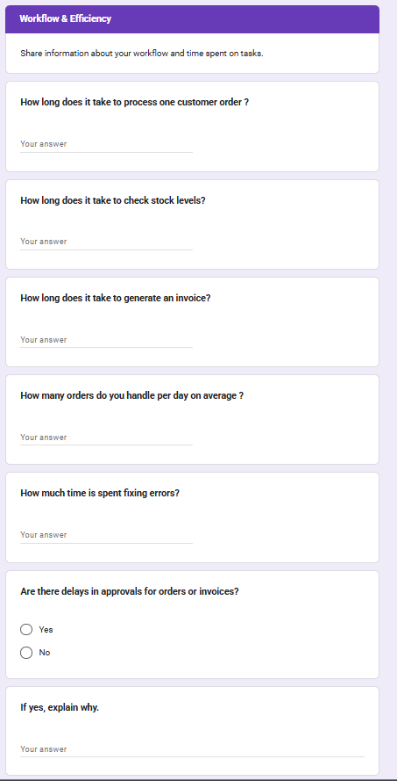
Figure 3
Figure 4

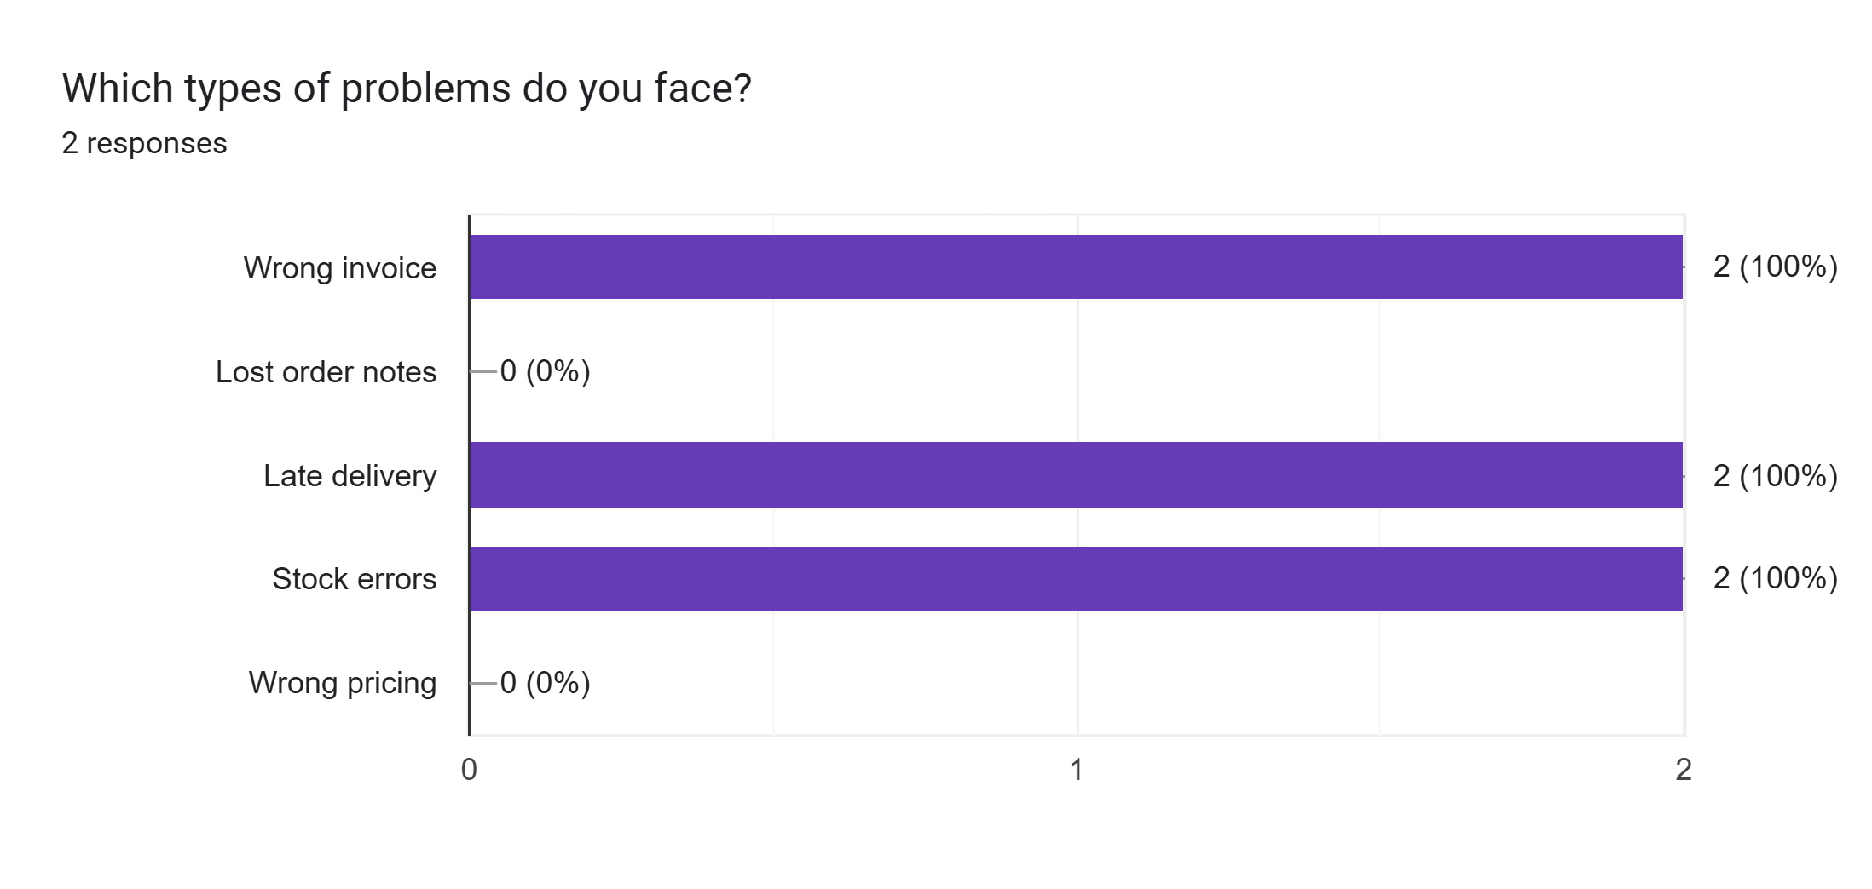
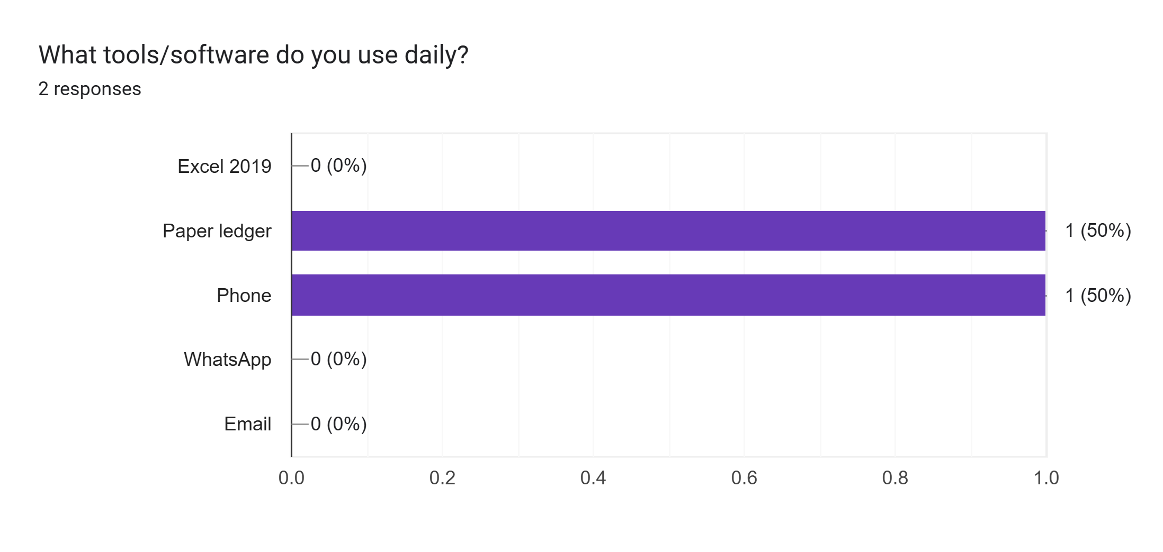
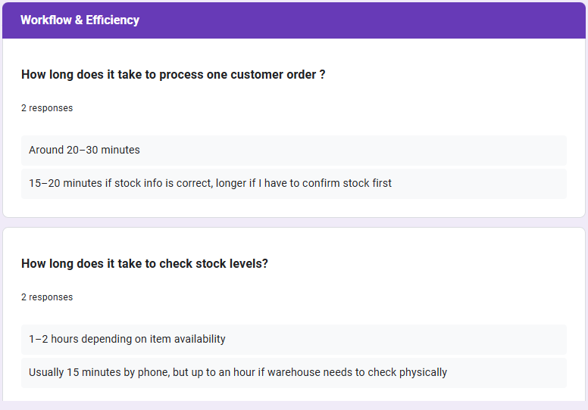
- Found: 73% reported daily stock discrepancies, with 61% citing manual data entry as the root cause.
Figure 5
Figure 6
Figure 7
Figure 8
- Follow-up Interviews
- Conducted interviews with three senior staff members to better understand the survey results.
- Discovered that missing items are often noticed only when customers place orders.
- Process Observation
- Observed stock checks over an 8-hour period across different shifts.
- Found that each stock reconciliation took 15–20 minutes longer because of the paper-based logs.

Current Stock System and Survey Results
RT & DK Consumers (Pvt) Ltd currently relies on a manual system to manage its stock. When a new order comes in, staff first write it down on paper and then enter the details into Excel. Similarly, invoices are prepared manually in Excel, and deliveries are organized through phone calls. The company does not use any dedicated software for tracking stock, generating reports, or providing real-time updates, which creates several challenges in day-to-day operations.
Main problems identified:
- No real-time updates: Staff have to check stock levels either by calling colleagues or by physically counting items, which is time-consuming.
- Frequent errors: Using paper notes and Excel increases the chances of mistakes, such as incorrect invoices or stock quantities.
- Slow process: Each order takes around 20–30 minutes to process, and completing a full stock check can take up to 2 hours.
- Delays in approvals: Orders and invoices often wait for manager approval, and if the manager is busy, this further slows down operations.
- Customer dissatisfaction: Errors in stock records and delays in deliveries result in unhappy customers and reduce overall service quality.

Survey conclusions:
- Inaccuracies: Stock records often do not match the actual physical stock available.
- Operational delays: Because updates are done manually, stock checks and order processing are slow.
- Stockouts: The company has no alert system, so products sometimes run out before staff are aware, affecting sales and customer satisfaction.
Overall, the current manual system is inefficient, prone to errors, and slows down the entire stock management process, highlighting the need for an automated inventory tracking solution.

Proposed System and Requirement Gathering
Proposed Solution
To address the inefficiencies of the current manual and Excel-based stock management system, RT & DK Consumers (Pvt) Ltd requires an automated inventory tracking system. This new system will streamline operations, reduce errors, and provide real-time information to all relevant staff. The key features of the proposed system include:
- Barcode/QR scanning: Each product will have a barcode or QR code, allowing staff to scan items directly into the system. This will reduce human errors during stock entry and ensure that all stock movements are recorded accurately.
- Real-time updates: The system will automatically update stock levels as orders are placed, deliveries are received, or stock is adjusted. This ensures that the stock information is always current, eliminating the need for manual checks.
- Low-stock and expiry alerts: Automatic notifications will be generated when stock levels fall below a minimum threshold or when products are nearing expiry. This helps avoid shortages, minimize waste, and ensures that customer orders can be fulfilled without delay.
- Reports and dashboards: The system will provide easy-to-read reports and dashboards covering sales, stock movements, and overall performance. Managers can use these insights to make informed decisions, identify trends, and optimize inventory management.
- User roles and access control: Different levels of access will be provided for staff, supervisors, and managers. This ensures that sensitive information is secure and that each user can only access the functions relevant to their role.
- Multi-device access: The system will be accessible from desktops, laptops, tablets, and mobile devices. This flexibility allows staff to manage stock, place orders, and monitor inventory from anywhere within the organization.
Overall, implementing this automated system will save significant time, improve accuracy in stock management, and support better customer service by reducing errors and delays.
Requirement Gathering Tools
To gather accurate requirements for the new system, both questionnaires and interviews were used. This approach ensures that the system is tailored to the actual needs of the staff and management.
Close-Ended Questions (Measurable):
- How do you currently track stock? (Manual / Excel / Software)
- How often do you update records? (Real-time / Daily / Weekly / Monthly)
- How many items do you manage? (<500 / 500–2000 / 2000–5000 / 5000+)
- What type of alerts do you prefer? (Email / SMS / System notification)
Open-Ended Questions (Detailed Feedback):
- What problems do you face with the current stock management system?
- What features would you like to see in the new system?
- Can you describe a recent stock issue that affected operations?
- Do you have any suggestions to improve stock management?

Interview Guide for Managers:
- What common problems do you notice with the current manual or Excel-based method?
- How do stock errors impact customers and overall business operations?
- Which reports or system features would be most useful to you?
- In your opinion, what should be the top priority when designing the new system?
Using this combination of questionnaires and interviews ensures that the proposed automated inventory tracking system will address the actual operational challenges, improve efficiency, and meet the needs of all users in the organization.

Standard Software Development Life Cycle
- Reach the best system:
        - SDLC ensures the system is well-planned, tested, and matches business needs, so RT & DK get a reliable and accurate solution.
- Finish on time with less cost:
        - Clear phases reduce delays and rework, saving money and helping the company get the system ASAP.
- Track and control progress:
        - Each stage is documented and visible, allowing RT & DK management to follow and guide development easily.
- High quality and future growth:
        - Proper testing and standard design give a stable system that is easy to maintain and expand as the business grows.

SDLC steps
- Planning
        - Defining project tasks, schedule, resources and scope to organize work, manage dependencies, and ensure objectives are achieved (Micro Soft, 2025).
- Communication (Requirement Gathering):
        - Collecting, clarifying and validating stakeholder needs via interviews, workshops and analysis to set accurate project goals and requirements. (IBM, n.d.).

- Designing
        - Creating the system’s structure, interfaces and layouts that translate requirements into architecture and user-facing designs for reliable, usable operation. (Massachusetts Institute Of Technology, 2015).

- Development & Testing
        - Coding the system and executing unit, integration and system tests to find defects and verify the software meets requirements and quality standards. (IEEE, 2019).
- Implementation (Deployment & Training)
        - Delivering and installing the system into production, training users, and maintaining it with updates, fixes and operational support. (Lee, 2019).

SDLC applied to RT & DK
- Planning
- Decide timeline, budget, and resources.
- At RT & DK: plan to shift from manual/Excel to automated system.
- That the main goal of the new system is to make daily operations faster by automating tasks that were previously done manually. It will reduce mistakes in stock records and orders, ensuring that inventory is accurate. At the same time, by providing timely and correct information, the system will help staff deliver better service to customers, leading to higher satisfaction and smoother business operations
  - Output: Feasibility Study Report.
  - Output: Project Plan Report.
- Communication (Requirements Gathering)
- This means understanding the actual requirements of the people who will use the system every day. By gathering their input, the system can be designed to address real problems, include the features they find most useful, and ensure it is easy for them to use. This step helps make the system more effective and user-friendly.

- At RT & DK: surveys, interviews, and observations showed stock errors, delays, and no real-time updates.
- Clear needs identified: barcode scanning, real-time updates, low-stock alerts, and reports.
  - Output: System Requirement Specification (SRS).
- Designing
- System Blueprint:
Create diagrams and flowcharts showing how data moves.
- Interface Plan:
Sketch simple screens for staff to enter and view stock.
- Database Design:
Define tables for products, stock, sales, and users.
- Validation Rules:
Set rules to reduce errors (e.g., no duplicate stock entries).
  - Output: System Design Specification (SDS/DDS).

- Development & Testing
- Build core:
        - barcode/QR scanning, real-time sync, dashboards, alerts, multi- device, Excel import.
- Test plan:
        - unit, integration, system, security; include offline use and device compatibility.
- Validate data & speed:
        - That when information or stock data is imported into the system, it will be carefully checked to ensure it is correct. The system will automatically update dashboards to reflect current stock levels and generate alerts when necessary, such as low-stock warnings. All of this is done while ensuring that no data is lost, keeping the system reliable and accurate.
- Fix:
        - During the development and testing phase, all mistakes or defects in the system will be identified and fixed. After each correction, the system is tested again to ensure the fixes work correctly. This process continues until the system operates reliably, with no significant issues, and is ready for full use.
- Output: Source code + Technical documentation.
- Output: Test plan.
- Output: Test Cases.

- Implementation (Deployment & Maintenance)
- System rollout:
        - deploy the new inventory system to replace paper/Excel for daily use.
- Staff training:
        - train employees to handle scanning, invoicing, and dashboards.
- Smooth transition:
        - The new system is first introduced, any problems or errors that arise will be addressed immediately. Promptly resolving these issues ensures that stock records remain correct, orders are processed properly, and day-to-day operations run smoothly without interruptions.

- Maintenance & updates:
        - The system will be actively maintained after it is launched. Regular updates will fix any errors or bugs that appear, important data will be backed up to prevent loss, and new features can be added as needed. This ensures the system remains stable, secure, and able to meet the company’s needs as it grows in the future.
  - Output: User Manual.
  - Output: Maintenance and Support Plan.

Software process models
- Prescriptive (Waterfall / V-Model),
        - Not suitable.
        - that once the process or project begins, it cannot be modified easily. Any changes to requirements, design, or workflow are difficult to implement, which can lead to delays, errors, or additional costs if adjustments are needed later.
- Incremental,
        - Best.
        - The system is developed in small, manageable sections, allowing each part to be completed and tested quickly. If any changes are needed, they can be made without affecting the entire system, which saves time and reduces the cost of fixing errors or adding new features.

- Evolutionary (Spiral / Prototype),
        - Not needed.
        - This approach is suitable when the project’s goals, features, or user needs are not fully known at the start, or when there is a high chance of unexpected challenges. Using this method allows the system to be developed in stages, so changes and adjustments can be made as more information becomes available, reducing the risk of major problems later.

- Agile,
        - Good for working with users.
        - This approach is useful because it allows developers to involve users throughout the project. Users can test the system as it is being built, provide feedback, and highlight any issues. Developers can then fix problems quickly, ensuring the system meets user needs and reducing the chance of major errors after full implementation.

- Specialized (RAD / XP / DAD / Kanban),
        - This approach should be chosen only when the project has special requirements. For example, if the system needs to be developed very quickly, if high code quality is essential, or if the project is very large and complex, then this method can provide advantages. Otherwise, it may not be the most suitable choice for typical projects.

- Suggested Process Model: Incremental Model
The Incremental Model is the most suitable choice for RT & DK Consumers (Pvt) Ltd because it allows the development of the most important features first. Key functions such as barcode scanning, real-time stock updates, and low-stock alerts are implemented at the beginning, ensuring that the system can start providing value quickly. Additional features can then be added in later stages, making it easier and less expensive to make changes as needed. By using parts of the system early, staff can begin working with it immediately, which helps improve efficiency and identify any issues sooner. Overall, this model fits the company’s size and clearly defined needs, offering a flexible and cost-effective approach to developing the new inventory system.
Figure 9
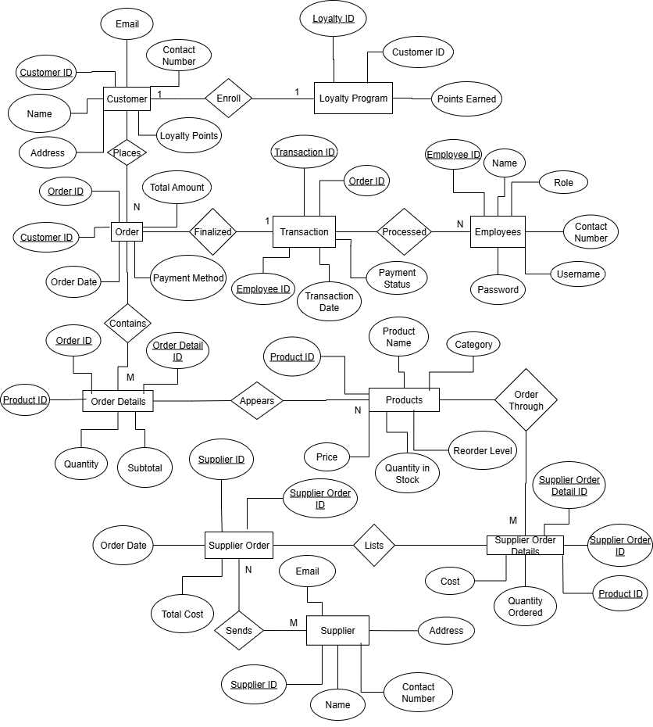

Product
Table 1
Attribute | Type | Description | Data Format | Field Size | Example
Product ID | Integer | Unique identifier for each product | Numeric | 6 | 100123
Product Name | Varchar | Name of the product | Text | 100 | “Plastic Water Jug”
Category | Varchar | Product category | Text | 50 | “Kitchenware”
Unit Price | Decimal | Price per unit | 0.00 | 10,2 | 450.00
Quantity in Stock | Integer | Current stock available | Numeric | 5 | 250
Reorder Level | Integer | Minimum stock level before alert | Numeric | 5 | 50
Expiry Date | Date | Expiry date for perishable products | YYYY-MM-DD | 10 | 2025-12-31
Barcode QR | Varchar | Barcode/QR code value | Alphanumeric | 50 | “8901234567890”
Customer
Table 2
Attribute | Type | Description | Data Format | Field Size | Example
Customer ID | Integer | Unique identifier for each customer | Numeric | 6 | 200567
Name | Varchar | Full name of customer | Text | 100 | “Nimal Perera”
Phone | Varchar | Customer contact number | +94XXXXXXXXX | 15 | “+94771234567”
Email | Varchar | Customer email address | Text | 100 | “nimal@gmail.com”
Address | Varchar | Customer address | Text | 200 | “Colombo, Sri Lanka”

Supplier
Table 3
Attribute | Type | Description | Data Format | Field Size | Example
Supplier ID | Integer | Unique identifier for each supplier | Numeric | 6 | 300789
Supplier Name | Varchar | Name of supplier company/person | Text | 100 | “Lanka Plastics Ltd”
Contact Number | Varchar | Supplier phone number | +94XXXXXXXXX | 15 | “+94776543210”
Email | Varchar | Supplier email address | Text | 100 | “info@lankaplast.com”
Address | Varchar | Supplier’s business address | Text | 200 | “Kurunegala, SL”
Sales Order
Table 4
Attribute | Type | Description | Data Format | Field Size | Example
Order ID | Integer | Unique sales order number | Numeric | 8 | 50012345
Customer ID | Integer | Links order to customer | Numeric | 6 | 200567
Order Date | Date Time | Date & time of order | YYYY-MM-DD hh: mm: ss | 19 | 2025-08-29 10:45:00
Total Amount | Decimal | Total cost of the order | 0.00 | 10,2 | 7850.00
Payment Status | Varchar | Status of payment | Text | 20 | “Paid” / “Pending”

Order Item
Table 5
Attribute | Type | Description | Data Format | Field Size | Example
Order Item ID | Integer | Unique identifier for each order item | Numeric | 8 | 80045678
Order ID | Integer | Links to Sales Order | Numeric | 8 | 50012345
Product ID | Integer | Product sold | Numeric | 6 | 100123
Quantity | Integer | Quantity sold in this order | Numeric | 5 | 12
Unit Price | Decimal | Unit price at time of sale | 0.00 | 10,2 | 450.00
Subtotal | Decimal | Line total (Quantity × Unit Price) | 0.00 | 10,2 | 5400.00
User
Table 6
Attribute | Type | Description | Data Format | Field Size | Example
User ID | Integer | Unique identifier for each system user | Numeric | 6 | 900111
Username | Varchar | Login username | Alphanumeric | 50 | “rtdk_admin”
Password | Varchar | Encrypted password | Encrypted | 100 | “$2a$12$...hash...”
Role | Varchar | User role (Staff / Supervisor / Manager) | Text | 20 | “Manager”
Email | Varchar | Staff email address | Text | 100 | “manager@rtdk.lk”

Context Level DFD

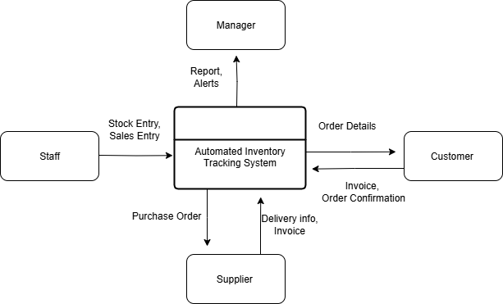
Figure 10

High Level DFD
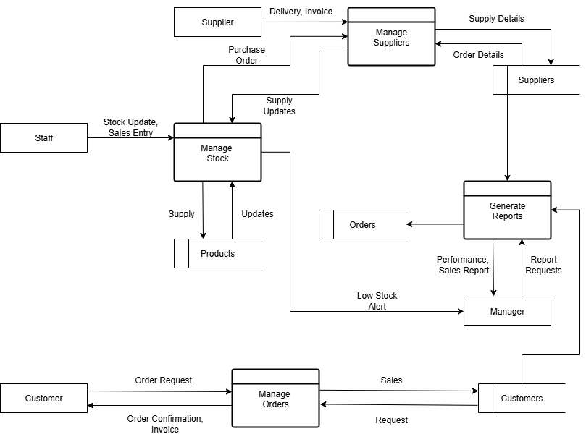
Figure 11

Structured English Method

PROCESS Automated Inventory Tracking System
BEGIN
FOR each Customer Order
IF stock is available
THEN generate Invoice
AND confirm Order to Customer
AND update Stock
ELSE
Notify Manager of Stockout
AND trigger Purchase Order to Supplier
ENDIF
END FOR

FOR each Supplier Delivery
Verify items received
Update Stock Records
Generate Supply Confirmation
END FOR

FOR each Manager Request
Generate Sales, Stock, and Performance Reports
END FOR
END

Decision Tree
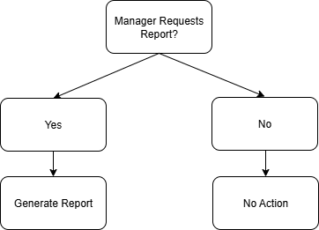
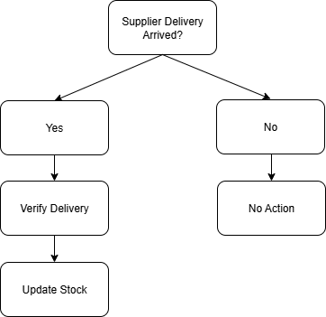
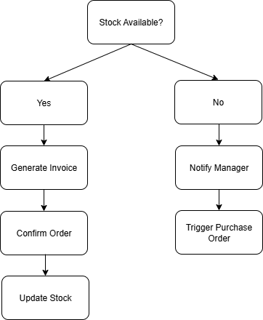
Figure 12
Figure 13
Figure 14

Decision Table
Table 7
Rule | C1 | C2 | C3 | A1 | A2 | A3 | A4
R1 | Y | - | - | X | - | X | -
R2 | N | - | - | - | X | - | -
R3 | - | Y | - | - | - | X | -
R4 | - | - | Y | - | - | - | X
Conditions
- C1 = Stock Available
- C2 = Supplier Delivery Arrived
- C3 = Manager Requests Report
Actions
- A1 = Confirm Order (Generate Invoice)
- A2 = Notify Manager (Stockout / Purchase Order)
- A3 = Update Stock
- A4 = Generate Report

Top Down Approach
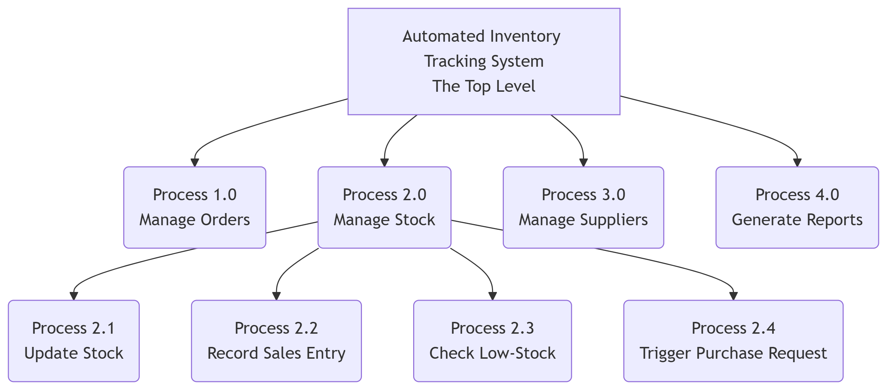
Figure 15

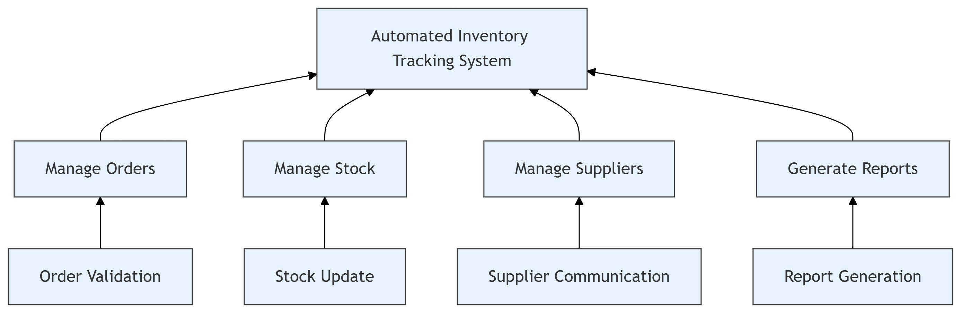
Bottom Up Approach
Figure 16

Use Case Diagram

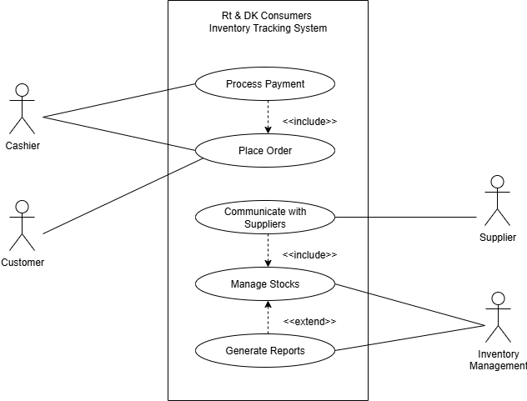

Sequence Diagram

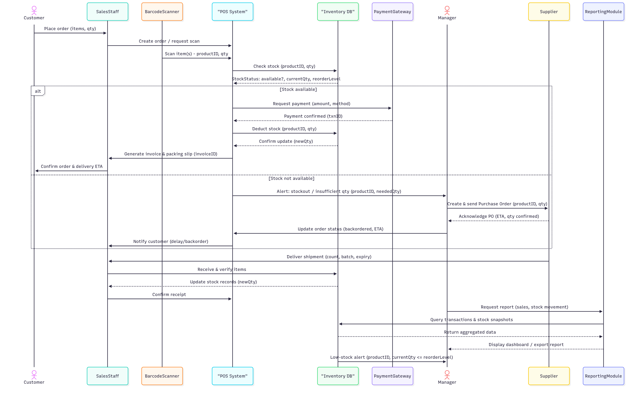

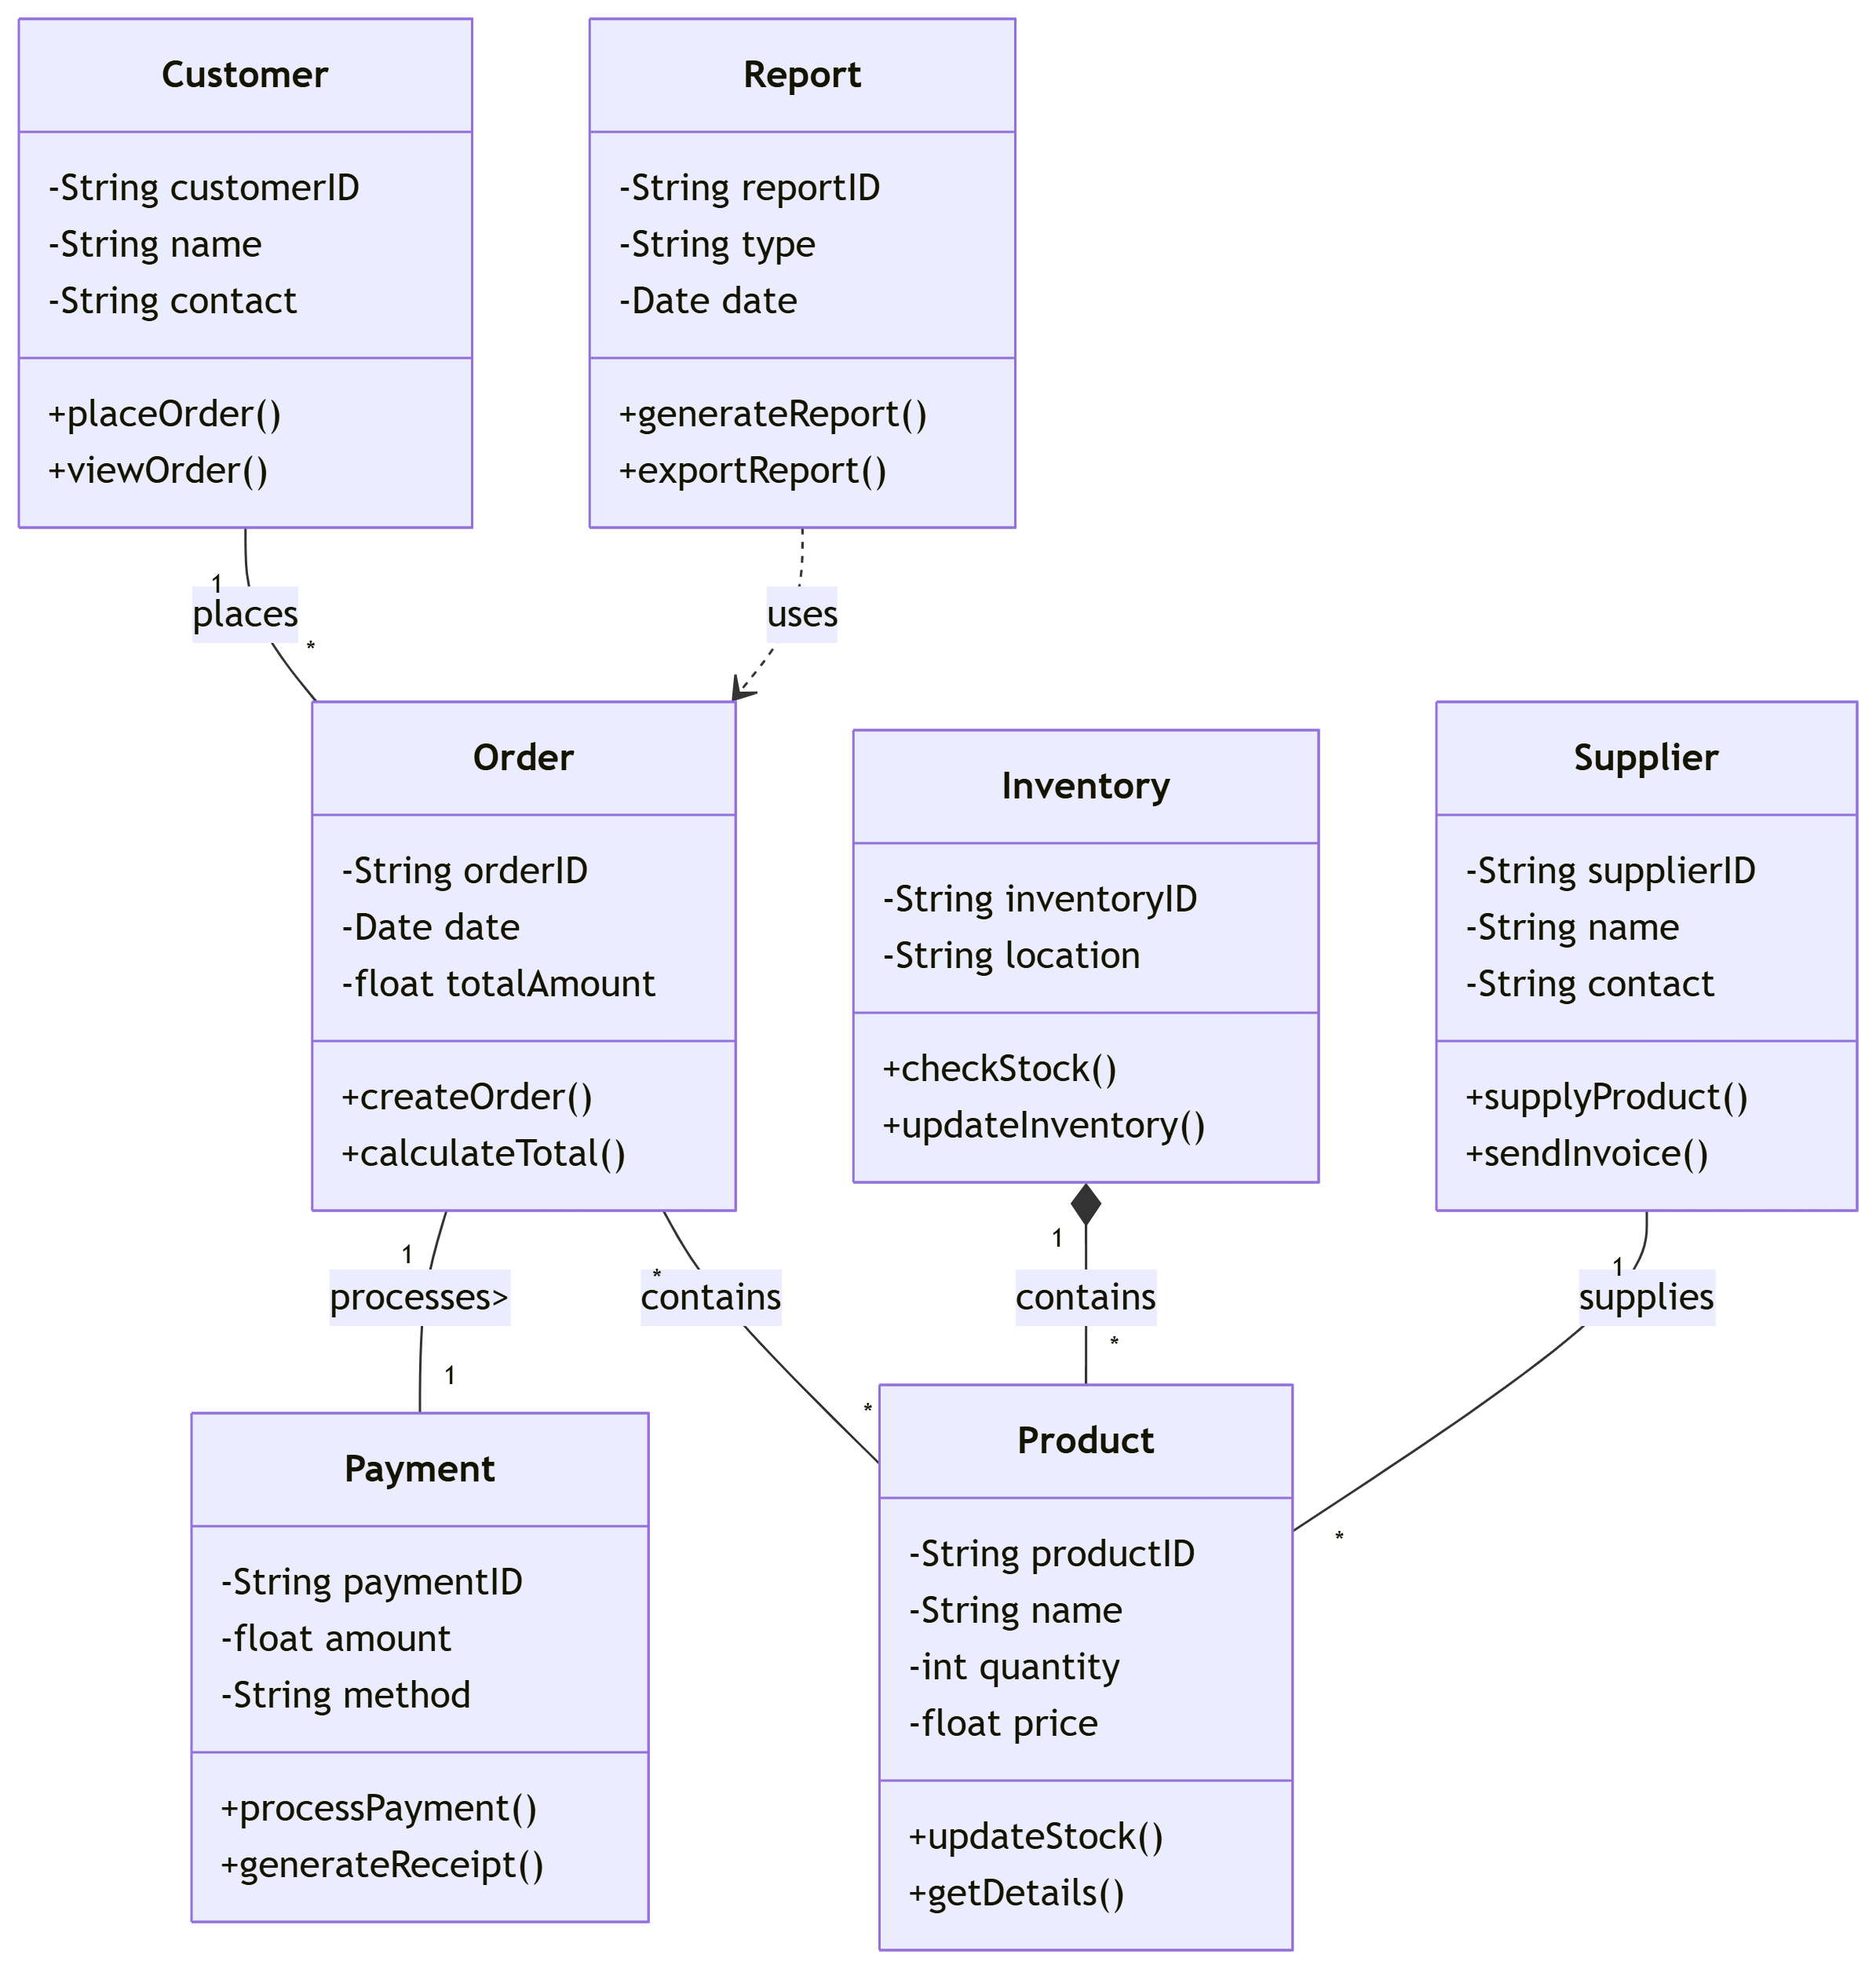
UML Class Diagram
Figure 17

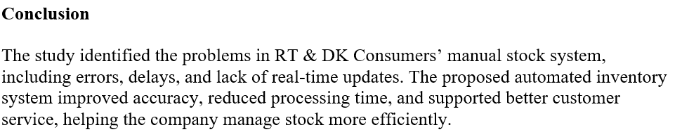

References
- IBM, n.d. What is requirements management?, s.l.: IBM.
- IEEE, 2019. ISO/IEC/IEEE International Standard - Software and systems engineering - Software testing -- Part 2: Test processes, s.l.: IEEE.
- Lee, R. Y., 2019. Implementation, s.l.: Springer Nature Link.
- Massachusetts Institute Of Technology, 2015. Fundemental Of System Engineering, s.l.: s.n.
- Micro Soft, 2025. Getting started: Introduction to project management, s.l.: s.n.

